How to use your NEXThaler inhaler
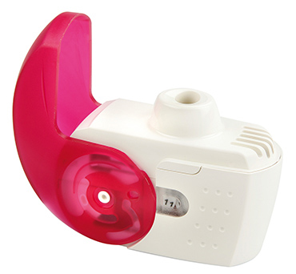
Inhalers are commonly prescribed for patients with asthma and chronic obstructive pulmonary disease (COPD) as they are very effective at delivering the medication straight to the lungs where it is needed.
Using your inhalers correctly is an important part of asthma or COPD treatment. You should be shown how to use inhalers properly by a healthcare professional when they are first prescribed.
You may occasionally experience problems using your inhalers, especially if it has been a while since you were shown the correct technique. This is very common and your healthcare professional can help you improve your inhaler technique.

Why is inhaler technique important?
- It allows the correct dose of medication to reach your lungs.
- It gives you better control of your condition.
Examples of NEXThaler inhalers | Fostair NEXThaler

Checklist for NEXThaler use
1 | Stand or sit upright when using your NEXThaler.
2 | Hold the NEXThaler firmly in the upright position and open the cover fully.
3 | Breathe out gently as far as is comfortable away from mouthpiece and do not breathe in again yet.
4 | Place the mouthpiece between your teeth without biting and form a good seal around it with your lips. Do not cover the air vent when holding the NEXThaler.
5 | Breathe in quickly and deeply through your mouth. You may hear or feel a click when you take your dose.
6 | Remove the NEXThaler from your mouth after inhaling and hold your breath for five to ten seconds or as long as is comfortable, then breathe out slowly.
7 | Replace the cover over the mouthpiece. Check the dose counter has reduced by one.
8 | If you need to take another dose repeat steps 2 to 7.

Common problems
Common mistakes that people make with NEXThalers include:
- Not inhaling strongly enough to draw the medication out of the NEXThaler and in to your lungs.
- Blocking the air vent or inhaling through the air vent.
- Not holding your breath long enough after breathing in the contents.
- Breathing out through the NEXThaler (remove the NEXThaler from your mouth first).
- Not replacing the cover over the mouthpiece.

Useful tips
- Do not remove the NEXThaler from the pouch unless you are ready to use it.
- Before first use, remove the NEXThaler from the pouch.
- Do not use the NEXThaler if it is more than six months since it was removed from the pouch.
- Always check that nothing is blocking the mouthpiece.
- You may notice a taste when you inhale the medicine.
- Always close the cover over the mouthpiece after use.
- Normally, it is not necessary to clean your NEXThaler, but if you need to clean it use a dry cloth or tissue. Keep your NEXThaler dry, do not use water.
- Speak to your nurse or pharmacist if you experience problems opening or using your NEXThaler.
- Always read the patient leaflet provided with your NEXThaler for any specific instructions.

How did I do?

For video demonstrations on how to use your inhaler visit:

https://player.vimeo.com/video/180738083

Ensure that you have your respiratory condition and inhaler technique reviewed at least annually

